**1.Provide the list of markets in which customer "Atliq Exclusive" operates its business in the APAC region.**

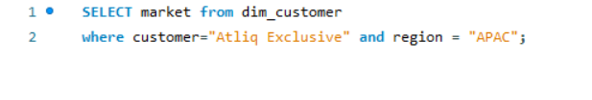

**2. What is the percentage of unique product increase in 2021 vs. 2020? The final output contains these fields, unique_products_2020 unique_products_2021 percentage_chg ?**

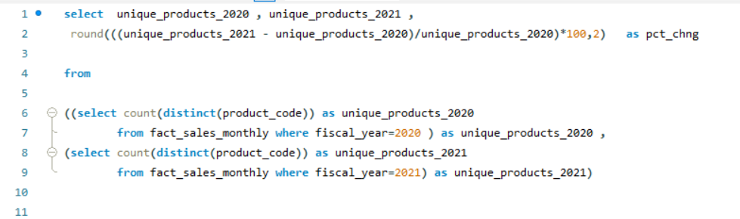

**3. Provide a report with all the unique product counts for each segment and sort them in descending order of product counts. The final output contains 2 fields, segment product_count?**

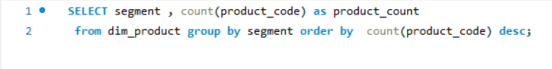

**4. Follow-up: Which segment had the most increase in unique products in 2021 vs 2020? The final output contains these fields, segment product_count_2020 product_count_2021 difference?**

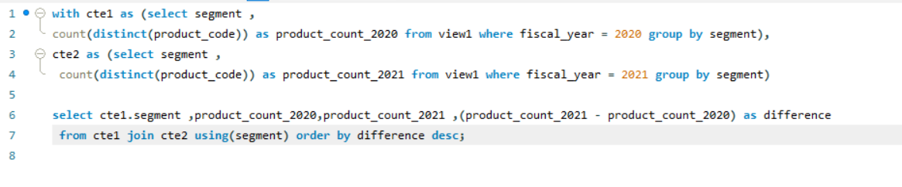

**5. Get the products that have the highest and lowest manufacturing costs. The final output should contain these fields, product_code product manufacturing_cost ?**

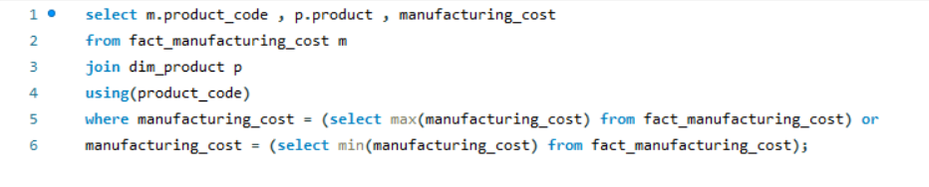

**6. Generate a report which contains the top 5 customers who received an average high pre_invoice_discount_pct for the fiscal year 2021 and in the Indian market. The final output contains these fields, customer_code customer average_discount_percentage ?**

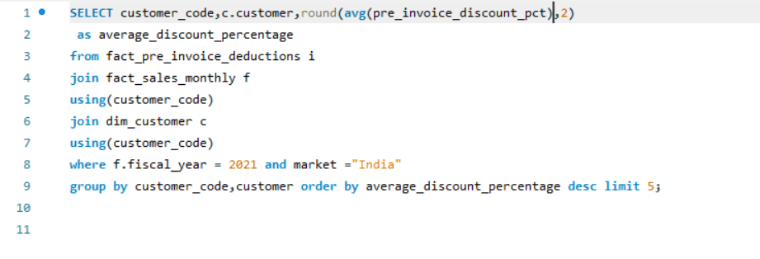

**7. Get the complete report of the Gross sales amount for the customer “Atliq Exclusive” for each month. This analysis helps to get an idea of low and high-performing months and take strategic decisions. The final report contains these columns: Month Year Gross sales Amount?**

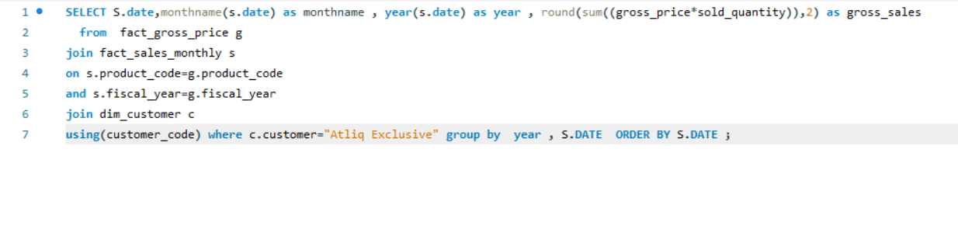

**8. In which quarter of 2020, got the maximum total_sold_quantity? The final output contains these fields sorted by the total_sold_quantity, Quarter total_sold_quantity?**

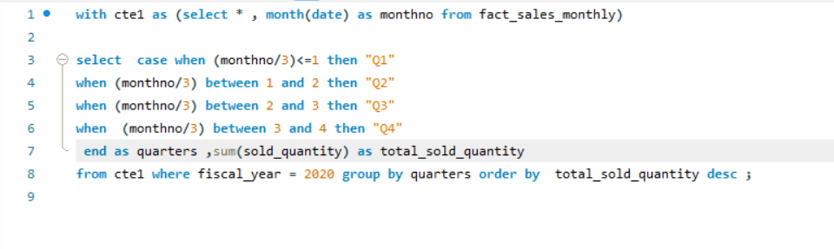

**9. Which channel helped to bring more gross sales in the fiscal year 2021 and the percentage of contribution? The final output contains these fields, channel gross_sales_mln percentage ?**

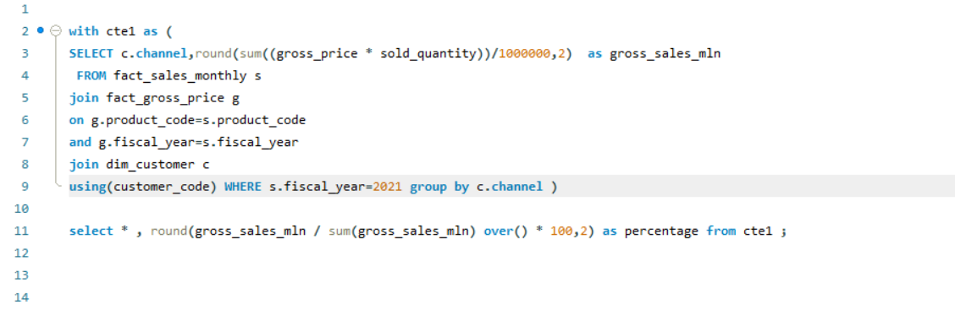

**10. Get the Top 3 products in each division that have a high total_sold_quantity in the fiscal_year 2021? The final output contains these fields, division product_code codebasics.io product total_sold_quantity rank_order?**

